

Milestone 1
Individual Evidence Pack

- College: College of Computing
- Major: Computer Science
- Group Number: Project Team 2
- Student Name: CHEN Xian
- Student Number: 59790558
- Milestone: M1

Polymarket signal analysis — detect unusual odds movements empirically
1 What I Contributed
- Lead the project discussion, selected and scoped the project topic. Confirmed "Polymarket signal analysis" as team topic.
- Researched Polymarket ecosystem: Investigated Gamma API (market metadata), CLOB API (order books), and official py-clob-client SDK.
- Defined data requirements: Identified 8 critical time-series fields for anomaly detection:
- Price signals: midpoint, best_bid, best_ask, spread
- Liquidity signals: bid_depth_top5, ask_depth_top5
- Temporal: timestamp, datetime
- Designed stratified sampling strategy: 3-tier approach (high/medium/low liquidity markets) to study relationship between liquidity and anomaly frequency
- Defined initial data requirements: Identified critical time-series features for anomaly detection (price jumps, volatility spikes, order book imbalance, spread widening).
- Defined team roles and workload for a 5-person group and Drafted preliminary roadmap covering data collection → feature engineering → anomaly definition → detection methods → empirical validation.
- Data Collection Progress (Test for 1 hours)
2 Evidence
- System Architecture Diagram
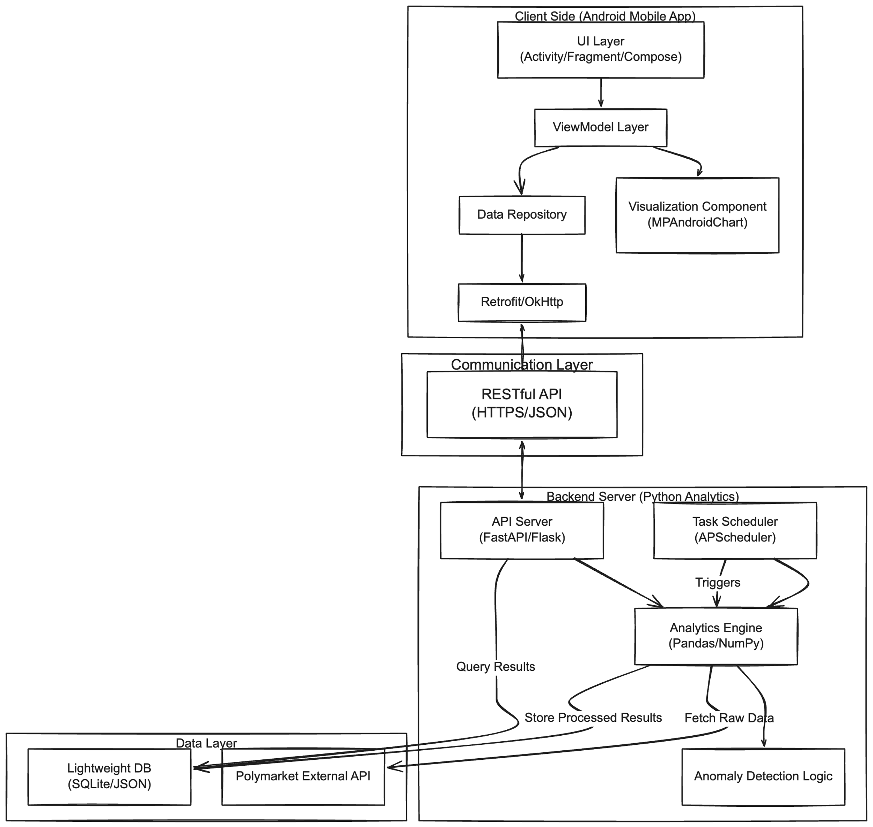
- GitHub Repository: https://github.com/SHANECHEN0722/pet-getdata.git
3 Validation Performed
Data Collection System Testing
What was tested:
End-to-end data pipeline from market selection → API polling → CSV storage
Method:
Ran python -m getdata.test (2-minute test mode) to validate:
API connectivity and authentication (unauthenticated read-only access)
Market filtering logic (150 → 12 markets)
Stratified sampling distribution (6:4:2 ratio)
Data collection for all 12 markets × 2 tokens = 24 time series
CSV file creation and schema correctness (8 fields)
Error handling (retries, timeouts)
Result:
PASS - All time series files created successfully
Market metadata: 12 rows written to market_metadata.csv
Time series: 3 data points per token
Schema validation: All 8 fields present (timestamp, datetime, midpoint, best_bid, best_ask, spread, bid_depth_top5, ask_depth_top5)
Zero API failures in test run

